NEWTON COUNTY COMMUNITY SERVICES, INC.
Reasonable Modification Policy

- Purpose
The purpose of the reasonable modification policy is to ensure that Newton County Community Services, Inc. offers equal and effective opportunities and access to public transportation services for persons with disabilities and full compliance with the provisions of the Title II of the Americans with Disabilities Act of 1990 and Section 504 of the Rehabilitation Act of 1973.

- Policy
Newton County Community Services, Inc. is committed to providing equal access and opportunity to qualified individuals with disabilities in all programs, services and activities. Newton County Community Services, Inc. recognizes that in order to have equally effective opportunities and benefits, individuals with disabilities may need reasonable modifications to policies and procedures. Newton County Community Services, Inc. will adhere to all applicable federal and state laws, regulations and guidelines with respect to providing reasonable modifications, as necessary, to afford equal access to programs for persons with disabilities. Newton County Community Services, Inc. does not discriminate on the basis of disability in admission to, participation in, or receipt of services and benefits under any transit program or activity. Newton County Community Services, Inc. will take appropriate steps to ensure that persons with disabilities have an equal opportunity to participate.

No qualified individual with a disability shall, by reason of such disability, be excluded from participation in or be denied the benefits of the services, programs, or activities of Newton County Community Services, Inc., or be subject to discrimination by Newton County Community Services, Inc.

- Reasonable Modifications
A reasonable modification is a change or exception to a policy, practice, or procedure that allows disabled individuals to have equal access to programs, services, and activities. Newton County Community Services, Inc. will make reasonable modifications to policies, practices and procedures when necessary to ensure access to transit services for qualified individuals with disabilities, unless:

- Making the accommodation would fundamentally alter the nature of the public transportation service.

- Making the accommodation would create a direct threat to the health or safety of other passengers.

- The individual with a disability is able to fully use Newton County Community Services, Inc.’s service without the accommodation being made.

For the purposes of this section, the term reasonable accommodation shall be interpreted in a manner consistent with the term ‘‘reasonable modifications’’ as set forth in the Americans with Disabilities Act Title II regulations at 28 CFR 35.130(b)(7), and not as it is defined or interpreted for the purposes of employment discrimination under Title I of the ADA (42 U.S.C. 12111–12112) and its implementing regulations at 29 CFR part 1630.

- Eligibility Criteria
An individual is eligible to be considered to receive a reasonable modification if that individual has: a physical or mental impairment that substantially limits one or more of the major life activities of such individual; a record of such impairment; or been regarded as having such impairment.

- Requests for Reasonable Modifications
Newton County Community Services, Inc. shall make information about how to contact Newton County Community Services, Inc. to make requests for reasonable modifications readily available to the public through its website and rider policy guidelines. Newton County Community Services, Inc. shall follow these procedures in taking requests:

  - Individuals requesting modifications shall describe what they need in order to use the service.

  - Individuals requesting modifications are not required to use the term ‘‘reasonable modification’’ when making a request. Personnel at Newton County Community Services, Inc. will determine if the request represents a reasonable modification and proceed in accommodating the request accordingly.

  - Whenever feasible, Newton County Community Services, Inc. requests that individuals make such requests for modifications before Newton County Community Services, Inc. is expected to provide the modified service.

  - Where a request for modification cannot practicably be made and determined in advance (e.g., because of a condition or barrier at the destination of a paratransit, demand response, or fixed route trip of which the individual with a disability was unaware until arriving), operating personnel shall make a determination of whether the modification should be provided at the time of the request. Operating personnel may consult with Newton County Community Services, Inc.’s management before making a determination to grant or deny the request.

Requests for accommodation may be made either orally or in writing. The reasonable accommodation process begins as soon as the request for accommodation is made.

The request can be submitted in any written format. Alternative means of filing a request, such as personal interviews, phone calls, or taped requests, will be made available for persons with disabilities if unable to communicate their request in writing or upon request.

- Interactive Process
When a request for accommodation is made, Newton County Community Services, Inc. and the individual requesting an accommodation must engage in a good faith interactive process to determine what, if any accommodation shall be provided. The individual and the Newton County Community Services, Inc. must communicate with each other about the request, the process for determining whether an accommodation will be provided, and the potential accommodations. Communication is a priority throughout the entire process.

- Time Frame for Processing Requests and Providing Reasonable Modification
Newton County Community Services, Inc. will process requests for reasonable accommodation and then provide accommodations, where appropriate, in as short a time frame as reasonably possible. Newton County Community Services, Inc. recognizes, however, that the time necessary to process a request will depend on the nature of the accommodation(s) requested and whether it is necessary to obtain supporting information.

- Granting a Reasonable Modification Request
As soon as Newton County Community Services, Inc. determines that a reasonable accommodation will be provided, that decision shall be immediately communicated to the individual. This notice must be in writing in order to maintain the required information for reporting purposes. Upon request, alternative means of response will be provided.

In choosing among alternatives for meeting nondiscrimination and accessibility requirements with respect to new, altered, or existing facilities, or designated or specified transportation services, Newton County Community Services, Inc. shall give priority to those methods that offer services, programs, and activities to qualified individuals with disabilities in the most integrated setting appropriate to the needs of individuals with disabilities.

- Denying a Reasonable Modification Request
As soon as Newton County Community Services, Inc. determines that a request for reasonable accommodation will be denied, Newton County Community Services, Inc. will communicate the basis for the decision in writing to the individual requesting the modification. The explanation for the denial will clearly state:

  - the specific reasons for the denial;

  - any alternative accommodation that may create the same access to transit services as requested by the individual; and

  - the opportunity to file a complaint relative to the Newton County Community Services, Inc.’s decision on the request.

- Complaint Process
Newton County Community Services, Inc. has a process for investigating and tracking complaints from qualified individuals. These procedures shall be posted on the Newton County Community Services, Inc.’s website and will be provided to any individual where the Newton County Community Services, Inc. has denied a request for accommodation. The process and any forms necessary to file a complaint are readily available from the web. Alternative means of filing complaints, such as personal interviews, phone calls, or taped requests, will be made available for persons with disabilities if unable to communicate their request in writing or upon request.

Any person who believes she or he has been discriminated against in obtaining a reasonable modification may file a complaint by completing and submitting a Newton County Community Services, Inc.’s Reasonable Modification Complaint Form. Newton County Community Services, Inc. investigates complaints received no more than 30 days after receipt. Newton County Community Services, Inc. will process complaints that are complete. Once the complaint is received, the complainant will receive an acknowledgement of receipt. If more information is needed to resolve the complaint, Newton County Community Services, Inc. may contact the complainant. The complainant has 30 business days from the date of the letter to send requested information to Newton County Community Services, Inc.

If Newton County Community Services, Inc. is not contacted by the complainant or does not receive the additional information within 30 business days, the Newton County Community Services, Inc. may administratively close the complaint. In addition, a complaint may be administratively closed if the complainant no longer wishes to pursue their case.

After Newton County Community Services, Inc. investigates the complaint, a decision will be rendered in writing to the complainant. Newton County Community Services, Inc. will issue either a Letter of Closure or Letter of Finding.

  - Letter of Finding – This letter will summarize the complaint, any interviews conducted regarding the complaint, and explains what actions will be taken by Newton County Community Services, Inc. to address the complaint.
  - Letter of Closure – This letter will explain why [Insert name of transit provider] has determined that the complaint does not merit accommodation under the Americans with Disabilities Act and that the complaint will be closed.

If the complainant disagrees with the decision of [Insert name of transit provider], an opportunity to appeal the decision may be pursued provided the complaint files notice of appeal within 21 days of the initial decision of Newton County Community Services, Inc.

In the event of appeal, the complainant will be granted all due process, including the ability to be present additional evidence, present the case in person during an appeal hearing, and to be represented by counsel.

- Designated Employee
Newton County Community Services, Inc. shall designate one official within the organization responsible for processing reasonable modification requests and handling complaints. This individual is:

Trisha Drain, Executive Director
Newton County Community Services, Inc.
213 E North St. PO Box 140
Morocco, IN 47963
219-285-2246
dir@nccs-inc.org

- Record Retention
Newton County Community Services, Inc. will maintain all records related to reasonable modification requests and denials for at least three (3) years.

______________________________________ __________
Executive Director Date

______________________________________ ___________
Board President Date
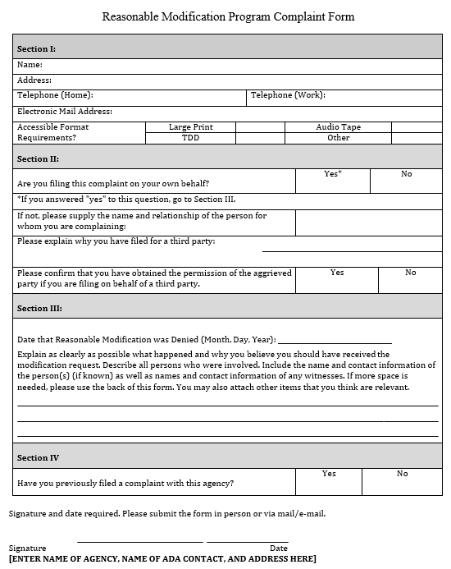
NEWTON COUNTY COMMUNITY SERVICES, INC.

NEWTON COUNTY COMMUNITY SERVICES, INC.
Once completed, please mail or email this form to:
Newton County Community Services
c/o Executive Director
P.O. Box 140
Morocco IN 47963
Email: dir@nccs-inc.org

- Requests for reasonable modifications may be denied on the following grounds:
- Granting the request would fundamentally alter the nature of Newton County
Community Services' service, programs, or activities;
- Granting the request could create a direct threat to the health or safety of the requestor or others;
- Granting the request would create an undue financial or administrative burden for the Agency; or
- Without such modification, the individual with a disability is otherwise able to fully use Newton County Community Services' services, programs, or activities for their intended purpose.
All reasonable modification requests will be acknowledged within seven (7) business days of receipt. The resolution and response to the person who submitted a request will be made within thirty (30) business days, or less if the circumstances warrant an immediate reaction, and the response will explain the reasons for the resolution. In any case in which NCCS denies a request for a reasonable modification, NCCS will take to the maximum extent possible any other actions (that would not result in a direct threat or fundamental alteration) to ensure that the passenger with a disability receives the services or benefits provided by NCCS to use the demand response paratransit service. Examples of Reasonable Modification requests that are not reasonable requests that either modify regulations or fundamentally alter the service include but are not limited to: asking for service outside the service area, asking that a passenger's ride be a direct ride (demand response transit is a shared-ride service), and/or asking a driver to act as a personal care attendant.
All information is kept confidential. All materials are available in accessible format and in languages other than English upon request.
FOR OFFICE USE ONLY
RECEIVED DATE: | RESPONDED DATE: | APPROVED/DENIED: | SIGNATURE:
NOTES REGARDING DECISION:

