SERVICE/SERVICE AREA
Newton County Community Services’ Public Transportation provides demand response, curb-to-curb public transportation service originating from Newton County to Newton County. Out of County Transportation will be considered based on availability within 120 miles of Newton County. Door-to-door service is also available upon request for those needing reasonable assistance beyond the curb.

All of Newton County Community Services’ Public Transportation operates as shared-ride service so it is common that passengers will be on board the vehicle with others who are traveling at the same time and in the same direction.

SERVICE HOURS
Monday thru Friday: 8:00 A.M. – 4:00 P.M.
Before/after hour transportation is based off of driver availability.

HOLIDAYS
Transportation Service is closed on New Year’s Day, Martin Luther King Day, President’s Day, Good Friday, Memorial Day, Juneteenth, Independence Day, Labor Day, Columbus Day, Veteran’s Day, Thanksgiving Day and Friday after, Christmas Eve and Christmas Day.

Accessibility
Individuals with mobility disabilities are welcome to use wheelchairs and manually powered mobility aids, i.e., walkers, crutches, canes, braces, or other similar devices designed for use by individuals with mobility disabilities. Vehicles with wheelchair lifts will accommodate standees upon request. Newton County Community Services’ Public Transportation also transports individuals traveling with portable oxygen tanks and respirators. For safety reasons, portable oxygen tanks must be able to be secured. * Please advise of mobility aids upon scheduling reservations.

REASONABLE MODIFICATIONS
Individuals needing a service accommodation or modification should notify Newton County Community Services’ Public Transportation of the request when making a reservation. For more information regarding the reasonable modification policy or how to file a reasonable modification complaint, please contact NCCS’ Public Transportation at (219)285-2246x2. Attempts will be made to honor all reasonable modification requests.

TRANSPORTATION OF CHILDREN
Children under 13 years old ride free with paying adult.

All children under 8 years old must be secured in a federally approved child restraint system, such as a rear-facing car seat or belt-positioning booster seat that matches their height and weight.

Car and booster seats are the responsibility of the parent or guardian and Newton County Community Services’ Drivers are not responsible for securing. This responsibility is left to the parent/guardian of the child.

FARES
Payment is expected at the time of ride.
Fares are based on mileage, determined from pick up point to drop off.

Payment options include Medicaid, TIIIB and Self Pay.

Medicaid/Medicare Transportation is scheduled by calling your Medical provider for payment AND us to schedule.
We are in network with:
Anthem: WellTrans 1-866-982-3983
Punch cards available for purchase.

SERVICE ANIMALS
Newton County Community Services’ Public Transportation welcomes service animals. Service animals must be under the constant control of its handler. Riders are NOT permitted to bring Non-Service animals on board.

TITLE VI
Newton County Community Services’ Public Transportation operates its programs and services without regard to race, color, or national origin in accordance with Title VI of the Civil Rights Act. Any person who believes she or he has been aggrieved by any unlawful discriminatory practice under Title VI or for more information on the civil rights program, or the procedures to file a complaint, contact (219)285-2246 ext. 5, (TTY 800-743-3333); email dir@nccs-inc.org or visit our administrative office at 102 E State St Morocco IN 47963. Complaints may be filed directly with the FTA with the Office of Civil Rights, Attention: Title VI Program Coordinator, East Building, 5th Floor-TCR, 1200 New Jersey Ave., SE Washington, DC, 20590.

Updated: DECEMBER 2025
by Trisha Drain, Executive Director

Newton COunty Public Transit

Mission Statement:
It is our mission to provide safe, reliable, affordable and efficient public transportation in Newton County.
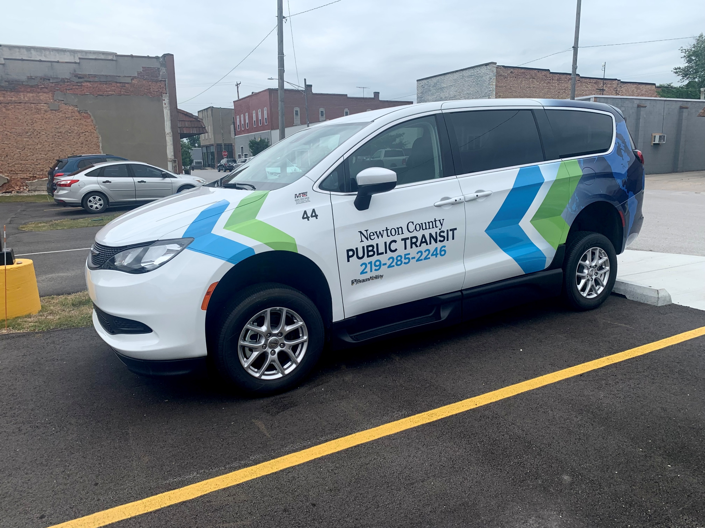

102 E State St
Morocco IN 47963
PO Box 140
Phone (219)285-2246 ext. 2
Fax (219)285-6726
Indiana Relay Service Dial 711 or
TTY (800)743-3333
(For the Hearing Impaired)

SERVICES FUNDED IN PART BY: The Federal Transit Administration 5311 Program, and the Indiana Department of Transportation Public Mass Transit Fund

Newton County Community Services is an Equal Opportunity Employer & a Drug-free workplace.

TRIP RESERVATIONS
All trips are scheduled in advance on a first come, first served basis and are scheduled on a time and space availability basis. Trip reservations may be requested a minimum of 72 hours in advance of requested pick up time, but 14 days prior to appointment is recommended. Same day appointments accepted as schedule permits.
To schedule trips passengers must call (219)285-2246x2 between 7:00 am – 4:00 p.m. Monday - Friday.
Trips CANNOT be scheduled by telling a driver.

Passengers must include the following information when scheduling trips:
- Name/DOB
- Telephone #
- Pick-up/Drop-off addresses
- Home Address
Hearing impaired persons can call the Indiana Relay Service at 711 or (800) 743-3333 for assistance in scheduling trips.

Same day add-on trips will be accommodated if there are openings on that day's schedule.

Please let us know if you have special needs such as if you are traveling in a wheelchair, with an attendant, service-animal, portable oxygen tank or respirator, etc.

An escort or personal care attendant may accompany you at no charge.

WILL CALLS
Sometimes it may not be possible to schedule a time for your return trip. If this is the case you can schedule a Will Call. With a Will Call you call when you are ready to go. Unfortunately, because Will Calls don't have a scheduled time there may be a long wait before you can be picked up. You may also have to wait for a bus that is heading to your part of the county. For best service you should only schedule a Will Call as a last resort.

PICK UP WINDOW
Newton County Community Services’ Public Transportation has a 15-minute pick-up window. This means that the unit can arrive to pick you up as early as 15 minutes prior to your pick up time. If there is no response or cannot board the vehicle within 15 minutes of our vehicle honking the horn at your home, you will be considered a No Show.

CANCELLATIONS AND NO SHOWS
It is important that if you don't need your trip that you cancel at least 24 business hours prior to your scheduled pickup time. Cancellations can be left on voicemail when office is closed. If the unit arrives to pick you up and the driver cannot locate you within 15 minutes or you have failed to cancel your trip at least 24 hours prior to your scheduled pickup time you will be considered a No Show. No Shows waste time and money, make other passengers late and cause service denials to others.

If you are reported as a No Show subsequent scheduled trips for that day are automatically cancelled until we hear from you to confirm your schedule. If you are recorded as a No Show for 3 or more of your scheduled rides within a 30-day period, your service will be suspended for 10-days. Habitual offenders will be required to tender missed fares prior to re-instatement. You can appeal your suspension by calling Newton County Community Services’ Public Transportation at (219)285-2247 ext. 2 to speak to the Transportation Director.

SAFETY
Seatbelts must be worn at all times while the vehicle is in motion. All wheelchairs must be secured with a 4-point securement system. Passengers must remain seated with seatbelts fastened until the vehicle has come to a complete stop.

RIDER COURTESY
Our service is shared ride. We expect you to be respectful and courteous to others. Please do not eat, drink, smoke or chew tobacco, vape, play loud music, engage in loud conversation, curse, or touch or disturb others on the bus.

PROHIBITED ACTIVITIES
Illegal acts, threats or acts of physical violence will not be tolerated. Newton County Community Services’ Public Transportation will contact law enforcement for assistance in threatening situations. Any rider who poses a “direct threat” to the health or safety of others will be denied service.

OTHER RESTRICTIONS
* Items large enough to block isle way; emergency exits
* Garbage, recycled material, aluminum cans
* Flammable materials such as Gasoline, oils, etc.
* Shopping carts of any kind
* Lawn mowers, weed eaters, bicycles
* No profanity / intimidation / fighting
* No opened food or drink on the buses
* No illegal drugs on any vehicle
Any violation of these rules outside of an ADA eligible Reasonable Accommodation, may result in immediate removal from vehicle as well as suspension of services.

ASSISTANCE
Our service is provided from the curb at your pick-up point to the curb of your destination.

The driver may assist you to and from the curb when boarding or leaving the bus, but is not permitted to enter a passenger’s residence or enter a facility that places the vehicle or other passengers outside of sight of the operator.

The driver is trained in passenger assistance and will secure all wheelchairs and help secure packages and assist with seatbelts if needed. However, Newton County Community Services Public Transportation requests that passengers not take advantage of this courtesy or drivers. It is the primary responsibility of the passenger or his/her attendant to load and unload bags/packages. Drivers will assist as needed.

Riders are requested to limit carry-on bags. A limit of 5 bags per person are allowed.

Weather closings and cancellations
Driver, passenger and public safety are our primary concerns. During adverse weather, delays or cancellations may occur. All closings and cancellations will be announced on 97.7 FM WLQI Radio Station as well as on our Newton County Community Services’ Facebook page.
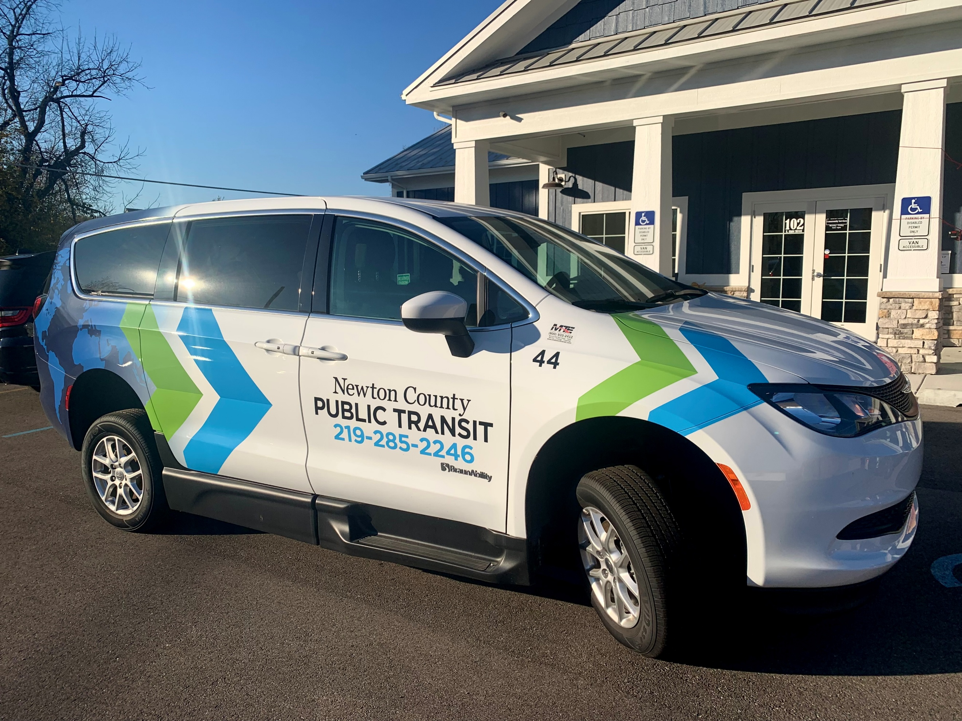

THIS BROCHURE IS AVAILABLE IN ALTERNATIVE FORMAT UPON REQUEST
Interpreter Services Are Available

